# NEWS TRACKER APPPLICATION

USING CLOUD

*A Project report submitted in partial fulfilment of 7th semester in degree of*

BACHELOR OF ENGINEERING

IN

# ELECTRONICS AND COMMUNICATION ENGINEERING

***Submitted by***

Team ID: PNT2022TMID24438

|  |  |
| --- | --- |
| Bhuvaneshwaran S | 113319106010 |
| Ashwin M | 113319106006 |
| Ragul Rathna T | 113319106061 |
| Mohan Kumar K | 113319106046 |



**DEPARTMENT OF ELECTRONICS AND COMMUNICATION**

**ENGINEERING**

**VELAMMAL INSTITUTE OF TECHNOLOGY**

**THIRUVALLUR-DISTRICT**

ANNA UNIVERSITY: CHENNAI 600025

# NOV-2022

# VELAMMAL INSTITUTE OF TECHNOLOGY

# THIRUVALLUR-DISTRICT

# (A Affiliated College of Anna University, Chennai)



**BONAFIDE CERTIFICATE**

Certified that this project report ”**NEWS TRACKER APPLICATION”** is the bona fide record work done by **Mr. BHUVANESHWARAN S (113319106010**), **Mr. ASHWIN M(113319106006**), **Mr. RAGUL RATHNA T** (**113319106061**) and **Mr. MOHAN KUMAR K(113319106046)** for **“HX 8001 PROFESSIONAL READINESS FOR INNOVATION, EMPLOYABILITY AND ENTREPRENEURSHIP”** in **VII** semester of **B.E.,** degree course **in Electronics and Communication Engineering** branch during the academic year of 2022 - 2023.

**ACKNOWLEDGEMENT**

The satisfactions that accompany the successful completion of any task would be incomplete without mentioning the people who made it possible by their constant guidance and encouragement crowned our efforts with success. We are grateful to our **Chairman Shri. M.V.Muthuramalingam** and our **Director Shri. M.V.M.Sasikumar** for facilitating us with this opportunity. Our sincere thanks to **Advisor’s Shri. K.Razak** and **Shri.M. Vasu** , **Principal Dr.N.Balaji** ,**Vice Principal Dr. S. Soundarajan** for their support. Our respected **Head of the Department** of **Electronics and Communication Engineering** **Dr.B. Sridevi**, Project Evaluator **Dr. R. Jothi Chitra** and **Dr.M.Sivarathinabala** and our **Industrial mentor** **Sai Priya** deserve a special note of thanks and gratitude for having extended their fullest cooperation and continuous suggestions to make this project successful. We also thank all the faculty members of Electronics and Communication Engineering department for their help during the course of this project. We also like to express our gratefulness to our beloved parents and our family members who have always provided backup with their unending moral support and of course momentary help too which we believe are the driving forces for the completion of the project.

Bhuvaneshwaran S (Lead)

Ashwin.M

Ragul Rathna T

Mohan Kumar K

# ABSTRACT

Everyone has the right to freedom of speech. However, this right is being misused to differentiate and attack others, physically or verbally, in the name of free speech. This discrimination is known as hate speech. Hate speech can be well-defined as language used to express hate towards a person or a group of people based on characteristics such as race, religion, ethnicity, gender, nationality, disability and sexual orientation. The increasing usage of social sites and information sharing has specified major benefits to humanity. However, this has also assumed rise to a variety of challenges including the spreading and sharing of hate speech messages. Thus, to solve this emerging issue in social media sites, recent studies employed a variety of machine learning and deep learning algorithms with text mining algorithm to automatically detect the hate speech messages on real time datasets. Hence, the aim of this Project is to analyses the comments on social networks using Natural Language processing technique (NLP) and Deep learning algorithm named as Back propagation neural network algorithm. Using NLP technique, can extract the keywords from user generated content and implement Back Propagation neural network to classify the text whether it is positive or negative. If it is negative means, automatically block the comments as per user wish and also block the friends based on pre-defined threshold values. Experimental results shows that the proposed framework implemented in real time social network site with improved notification .

# TABLE OF FIGURES

1. INTRODUCTION
   1. Project Overview
   2. Purpose
2. LITERATURE SURVEY
   1. Existing problem
   2. References
   3. Problem Statement Definition
3. IDEATION & PROPOSED SOLUTION
   1. Empathy Map Canvas
   2. Ideation & Brainstorming
   3. Proposed Solution
   4. Problem Solution fit
4. REQUIREMENT ANALYSIS
   1. Functional requirement
   2. Non-Functional requirements
5. PROJECT DESIGN
   1. Data Flow Diagrams
   2. Solution & Technical Architecture
   3. User Stories
6. PROJECT PLANNING & SCHEDULING
   1. Sprint Planning & Estimation
   2. Sprint Delivery Schedule
   3. Reports from JIRA
7. CODING & SOLUTIONING
   1. Feature 1
   2. Feature 2
   3. Database Schema (if Applicable)
8. TESTING
   1. Test Cases
   2. User Acceptance Testing
9. RESULTS
   1. Performance Metrics
10. ADVANTAGES & DISADVANTAGES
11. CONCLUSION
12. FUTURE SCOPE
13. APPENDIX

Source Code GitHub & Project Demo Link

**News Tracker Application**

# INTRODUCTION

Mobile app ecosystems are transforming patterns of news consumption. Until quite recently, reading the news was a niche use for smartphones [12], mostly for when users were ‘on the go’; now however, two in every three users of mobile devices in the US regularly access news and as many as one in five read in-depth news articles daily [2]; a similar picture is found in the UK [1]. This growth in mobile news access continues the migration of news consumers to the Internet.

# Project overview

As news is increasingly accessed on smartphones and tablets, the need for personalising news app interactions is apparent. We report a series of three studies addressing key issues in the development of adaptive news app interfaces. We first surveyed users’ news reading preferences and behaviors’; analysis revealed three primary types of reader. We then implemented and deployed an Android news app that logs users’ interactions with the app. We used the logs to train a classifier and showed that it is able to reliably recognise a user according to their reader type. Finally we evaluated alternative, adaptive user interfaces for each reader type. The evaluation demonstrates the differential benefit of the adaptation for different users of the news app and the feasibility of adaptive interfaces for news apps.

# Purpose

As our lives are very busy these days, we often feel we need more than 24 hrs. a day to cope up with everything we have in our schedule. Well, that's not possible but reducing the time by changing the conventional method of reading news can help. Just tell us what market news you're interested in and get a quick peek for the day. Only read what you feel is relevant and save your time. This app helps you to query for all information about Indices, Commodities, Currencies, Future Rates, Bonds, etc.… as on official websites.

# LITERATURE SURVEY

* 1. **Existing problem**

We often feel we need more than 24 hrs. a day to cope up with everything we have in our schedule. Well, that's not possible but reducing the time by changing the conventional method of reading news can help.

# References

Like articles, websites, blogs. <https://www.researchgate.net/>.

[**https://techvidvan.com/tutorials/android-news-app-project-source-code/**](https://techvidvan.com/tutorials/android-news-app-project-source-code/)[**https://www.ripublication.com/**](https://www.ripublication.com/)

* 1. **Problem Statement Definition**

1. The user needs a way to organize the news on daily basis so that he can cope up with daily events in his tight schedule.
2. The user wants to read news only about particular topics so that he can be informed about his interest.
3. The user wants to get informed from only certified news outlets . 4.The user needs a way to search about the news on topics he wants to.

5. The user wants to know the news about his surrounding using GPS location.

# IDEATION & PROPOSED SOLUTION

* 1. **Empathy Map Canvas**

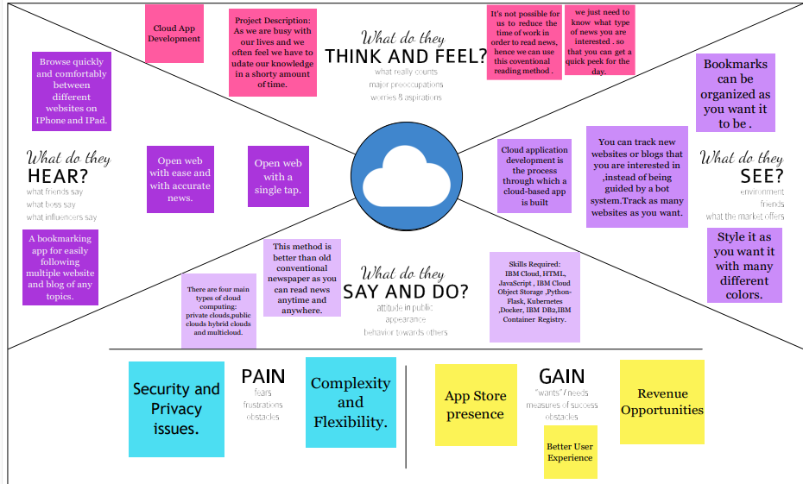

# 3.1.2 Ideation & Brainstorming

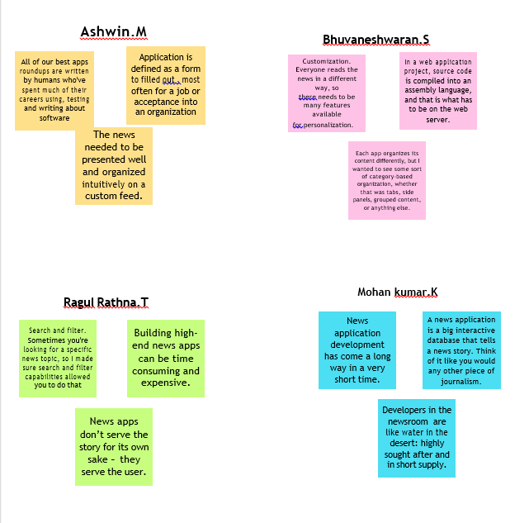

* 1. **Proposed Solution**

|  |  |  |
| --- | --- | --- |
| **S.NO** | **PARAMETERS** | **DESCRIPTION** |
| **1.** | Problem statement (problems to be solved | In our daily life, we come across various events of local as well as national importance, and to know it, we take the help of NEWS. But recently we realized there is no such common platform that provides both. So we found a Social Need and built a platform that helps to solve the problem. |
| **2.** | Idea/solution description | There are many news apps available that can keep you abreast of the latest happenings. When you want news from multiple sources, try New shunt, Pulse, Flip board , Zite . News Republic and News 360.The other alternatives of course are the dedicated news apps from media sources/publications. For instance , The Economic Times and Times of India have free apps across platforms |
| **3.** | Novelty/Uniqueness | In our daily life, we come across various events of local as well as national importance, and to know it, we take the help of NEWS. But recently we realized there is no such common platform that provides both. So we found a social need and built a platform that provides such news in form of short videos that are taken from them out trusted resources in the world. |
| **4.** | Social Impact/Customer satisfaction | Mobile devices have changed the way everyone lives. Here is a list of some amazing Social Good apps that can be used for a variety of different things. Some of these apps can be used on a day to day basis, others can be used for research, and some can be used to educate. No matter the reason, these mobile apps gives you the ability to stay consumer conscious And socially involved in every facet of your life |
| **5.** | Business Model (Revenue) | News apps are trying to be Model) like social media apps Businesses have to publish irrelevant news because younger generations prefer news with more fun instead of reliable news. News apps want to increase the time that user spends on their app So that they can show ads and generate revenue. |
| **6.** | Scalability of the solution | • Better user experience  • Cost-effectiveness  • Stable performance  • App customization  • Project growth |

# Problem Solution fit

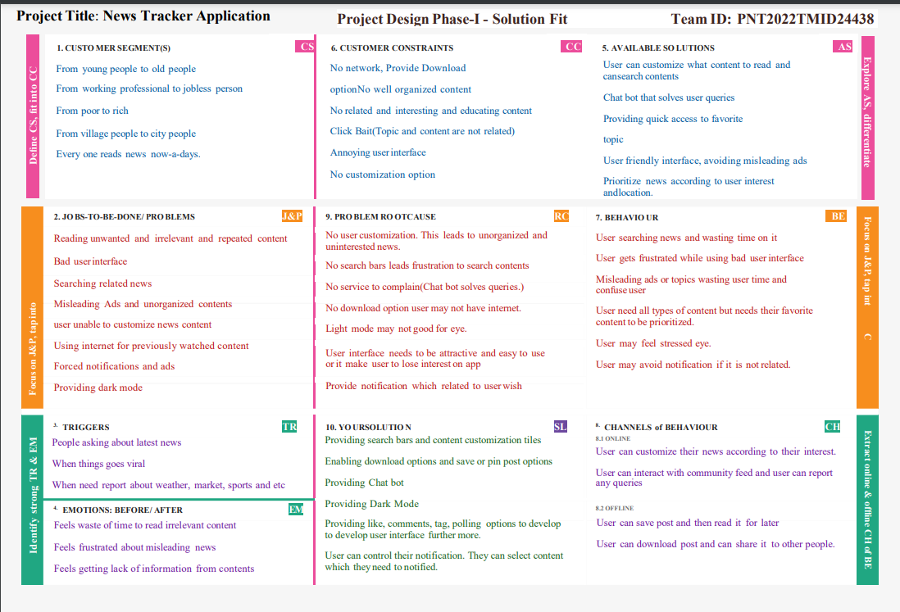

1. **REQUIREMENT ANALYSIS**

# Functional requirement

Following are the functional requirements of the proposed solution.

|  |  |  |
| --- | --- | --- |
| **FR**  **No.** | **Functional**  **Requirement (Epic)** | **Sub Requirement (Story / Sub-Task)** |
| FR-1 | User Registration | Registration through Form Registration through Gmail  Registration through website. |
| FR-2 | User Confirmation | Confirmation via Email Confirmation via OTP |
| FR-3 | User Login | Login through browser directly by entering  username and password  Login through  Login through email |
| FR-4 | User interaction | Done through user interface between client  and server View the related news by subscripted or requested page. |

# Non-functional Requirements:

Following are the non-functional requirements of the proposed solution.

|  |  |  |
| --- | --- | --- |
| **FR**  **No.** | **Non-Functional**  **Requirement** | **Description** |
| NFR- 1 | **Usability** | End users can receive push updates for  new content on a site by subscribing to  the site’s news feed |
| NFR- 2 | **Security** | How well are the system and its data  protected against attacks |
| NFR- 3 | **Reliability** | How often does the system experience  critical failures? How much time does it  take to fix the issue when it arises ?And  how is user availability time compared to  downtime? |
| NFR- 4 | **Performance** | Performance is the core non-functional  requirements no system can do without.It  defines how fast a software system or a  particular piece of it responds to certain  users actions under a certain workload. In  most cases, this metric explains how long  a user must wait before the target  operation happens (the page renders, a  transaction is processed, etc.) given the  overall number of users at the moment.  But it’s not always like that. Performance  requirements may describe background  processes invisible to users, e.g. backup.  But let’s focus on user-centric  performance. |
| NFR- 5 | **Availability** | Availability describes how likely the  system is accessible to a user at a given  point in time. While it can be expressed  as an expected percentage of successful  requests, you may also define it as a  percentage of time the system is  accessible for operation during some time  period. For instance, the system may be  available 98 percent of the time during a  month. Availability is perhaps the  most business-critical requirement, but to  define it, you also must have estimations  for reliability and maintainability. |
| NFR- 6 | **Scalability** | Scalability assesses the highest workloads under which the system will still meet the performance requirements. There are two ways to enable your system scale as the workloads get higher: horizontal and vertical scaling. |

# PROJECT DESIGN

* 1. **Data Flow Diagrams**

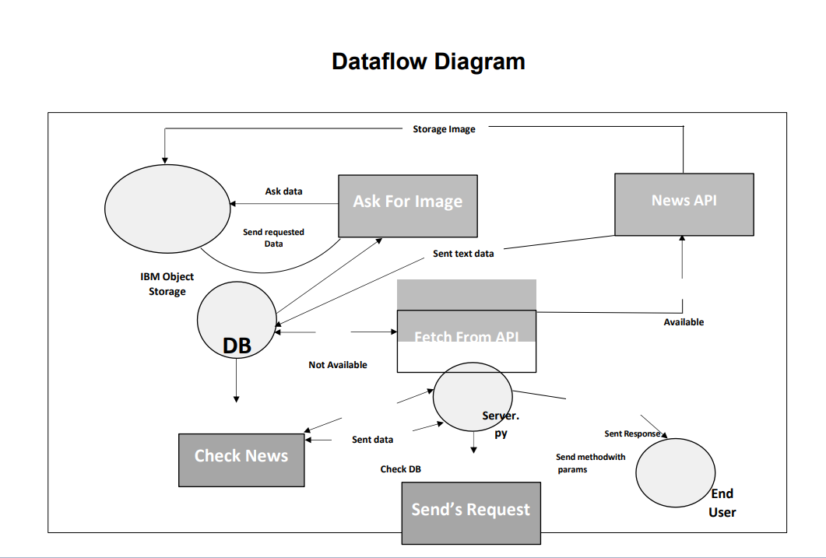

# Solution & Technical Architecture

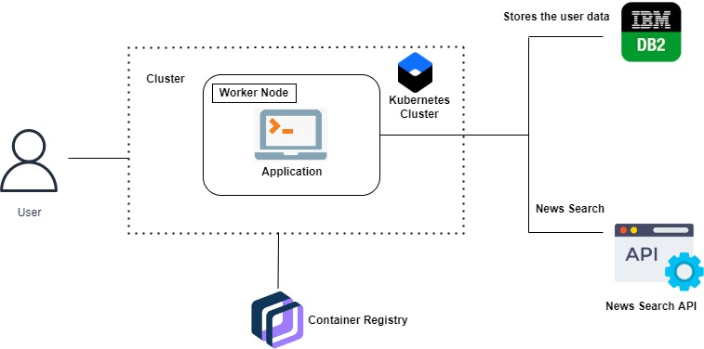

* 1. **User Stories**

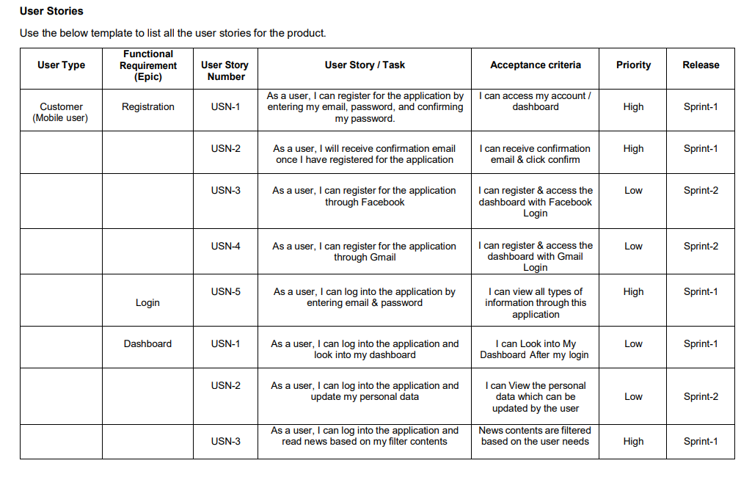

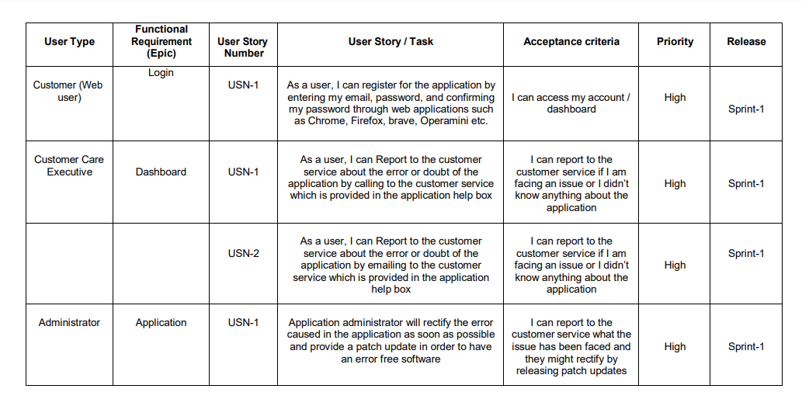

# PROJECT PLANNING & SCHEDULING

* 1. **Sprint Planning & Estimation**

|  |  |  |
| --- | --- | --- |
| TITLE | DESCRIPTION | DATE |
| Literature Survey & Information Gathering | Literature survey on the selected project & gathering information by referring the technical papers, research publications etc. | 6 OCTOBER 2022 |
| Prepare Empathy Map | Prepare Empathy Map Canvas to capture the user Pains & Gains, Prepare list of problem statements | 6 OCTOBER 2022 |

|  |  |  |
| --- | --- | --- |
| Ideation Brain Storming | List the by organizing the brainstorming session and prioritize the top 3 ideas based on the feasibility & importance. | 6 OCTOBER 2022 |
| Proposed Solution | Prepare the proposed solution document, which includes the novelty, feasibility of idea, business model, social  impact, scalability of solution, etc. | 6 OCTOBER 2022 |
| Problem Solution Fit | Prepare problem solution fit document | 17 OCTOBER 2022 |
| Solution Architecture | Prepare solution architecture document. | 17 OCTOBER 2022 |
| Customer Journey | Prepare the customer journey maps to | 17 OCTOBER 2022 |

|  |  |  |
| --- | --- | --- |
|  | Understand the user interactions & experiences with the application (entry to exit). |  |
| Data Flow Diagrams | Draw the data flow diagrams and submit for review. | 17 October 2022 |
| Technology Architecture | Prepare the technology architecture diagram. | 17 October 2022 |
| Prepare Milestone & Activity  List | Prepare the milestones & activity list of the project. | 3 NOVEMBER 2022 |
| Project Development - Delivery of Sprint-1, 2, 3  & 4 | Develop & submit the developed code by testing it. | IN PROGRESS.. |

# Sprint Delivery Schedule

# 

* 1. **Reports from JIRA**

# ------------------------------------------------------------------------------------------------

**----------------**

# CODING & SOLUTIONING

Forgot password- Forpass.html

<!doctype html>

<html lang="en">

<head>

<meta charset="utf-8">

<meta name="viewport" content="width=device-width, initial-scale=1">

<meta name="description" content="">

<meta name="author" content="Mark Otto, Jacob Thornton, and Bootstrap contributors">

<meta name="generator" content="Hugo 0.84.0">

<title>Sign In</title>

<link rel="canonical" href="https://getbootstrap.com/docs/5.0/examples/sign- in/">

<link href="https://getbootstrap.com/docs/5.0/assets/css/docs.css" rel="stylesheet">

<!-- Bootstrap core CSS -->

<link href=["ht](https://cdn.jsdelivr.net/npm/bootstrap%405.2.1/dist/css/bootstrap.min.css)t[ps://cdn.jsdelivr.net/npm/bootstrap@5.2.1/dist/css/bootstrap.min.css](https://cdn.jsdelivr.net/npm/bootstrap%405.2.1/dist/css/bootstrap.min.css)" rel="stylesheet" integrity="sha384-

iYQeCzEYFbKjA/T2uDLTpkwGzCiq6soy8tYaI1GyVh/UjpbCx/TYkiZhlZB6+ fzT" crossorigin="anonymous">

<!-- Favicons -->

<link rel="apple-touch-icon" href="/docs/5.0/assets/img/favicons/apple-touch- icon.png" sizes="180x180">

<link rel="icon" href="/docs/5.0/assets/img/favicons/favicon-32x32.png" sizes="32x32" type="image/png">

<link rel="icon" href="/docs/5.0/assets/img/favicons/favicon-16x16.png" sizes="16x16" type="image/png">

<link rel="manifest" href="/docs/5.0/assets/img/favicons/manifest.json">

<link rel="mask-icon" href="/docs/5.0/assets/img/favicons/safari-pinned- tab.svg" color="#7952b3">

<link rel="icon" href="/docs/5.0/assets/img/favicons/favicon.ico">

<meta name="theme-color" content="#7952b3">

<style>

.bd-placeholder-img { font-size: 1.125rem; text-anchor: middle;

-webkit-user-select: none;

-moz-user-select: none; user-select: none;

}

@media (min-width: 768px) {

.bd-placeholder-img-lg { font-size: 3.5rem;

}

}

</style>

<!-- Custom styles for this template -->

<link href="static/sheets/signin.css" rel="stylesheet">

<link href="static/sheets/colors.css" rel="stylesheet">

</head>

<body class="text-center">

<nav class="navbar navbar-dark bg-dark fixed-top">

<div class="container-fluid">

<a class="navbar-brand" href="#">News Tracker</a>

<button class="navbar-toggler" type="button" data-bs- toggle="offcanvas" data-bs-target="#offcanvasDarkNavbar" aria- controls="offcanvasDarkNavbar">

<span class="navbar-toggler-icon"></span>

</button>

<div class="offcanvas offcanvas-end text-bg-dark" tabindex="-1" id="offcanvasDarkNavbar" aria-labelledby="offcanvasDarkNavbarLabel">

<div class="offcanvas-header">

<h5 class="offcanvas-title"

id="offcanvasDarkNavbarLabel">Profile</h5>

<button type="button" class="btn-close btn-close-white" data-bs- dismiss="offcanvas" aria-label="Close"></button>

</div>

<div class="offcanvas-body">

<ul class="navbar-nav justify-content-end flex-grow-1 pe-3">

<li class="nav-item">

<a class="nav-link active" aria-current="page" href="home.html">Home</a>

</li>

<li class="nav-item">

<a class="nav-link" href="base.html">Fetch News</a>

</li>

<li class="nav-item">

<a class="nav-link" href="about.html">About Us</a>

</li>

<li class="nav-item">

<a class="nav-link" href="signin.html">Sign In</a>

</li>

<li class="nav-item">

<a class="nav-link" href="signup.html">Sign Up</a>

</li>

</div>

</div>

</div>

</nav>

<main class="form-signin ">

<form action = "{{ url_for("getUser")}}" method="POST">

<img class="mb-4" src="static/Images/house-user-solid.svg" alt="" width="72" height="57">

<h1 class="h3 mb-3 fw-normal white">Change your password</h1>

<div class="form-floating">

<input type="email" class="form-control" id="floatingInput" name = "uname" placeholder[="n](mailto:name@example.com)a[me@examp](mailto:name@example.com)l[e.com">](mailto:name@example.com)

<label for="floatingInput">Email address</label>

</div>

<br>

<button class="w-100 btn btn-lg btn-warning btn-outline-warning" type="submit"><a href="static/templates/changepass.html">Change Password</a></button><br><br>

</form>

</main>

<script src=["http](https://cdn.jsdelivr.net/npm/bootstrap%405.2.1/dist/js/bootstrap.bundle.min.j)s[://cdn.jsdelivr.net/npm/bootstrap@5.2.1/dist/js/bootstrap.bundle.min.j](https://cdn.jsdelivr.net/npm/bootstrap%405.2.1/dist/js/bootstrap.bundle.min.j) s" integrity="sha384-

u1OknCvxWvY5kfmNBILK2hRnQC3Pr17a+RTT6rIHI7NnikvbZlHgTPOOm Mi466C8" crossorigin="anonymous"></script>

<script src="[https://cdn.jsdelivr.net/npm/@docsearch/js@3](https://cdn.jsdelivr.net/npm/%40docsearch/js%403)"></script>

<script src=["http](https://cdn.jsdelivr.net/npm/%40stackblitz/sdk%401/bundles/sdk.umd.js)s[://cdn.jsdelivr.net/npm/@stackblitz/sdk@1/bundles/sdk.umd.js](https://cdn.jsdelivr.net/npm/%40stackblitz/sdk%401/bundles/sdk.umd.js)"></sc ript>

<script src="/docs/5.2/assets/js/docs.min.js"></script>

<script>

document.querySelectorAll('.btn-edit').forEach(btn => { btn.addEventListener('click', event => {

const htmlSnippet = event.target.closest('.bd-code- snippet').querySelector('.bd-example').innerHTML

const classes = Array.from(event.target.closest('.bd-code- snippet').querySelector('.bd-example').classList).join(' ')

const jsSnippet = event.target.closest('.bd-code-snippet').querySelector('.btn- edit').getAttribute('data-sb-js-snippet')

StackBlitzSDK.openBootstrapSnippet(htmlSnippet, jsSnippet, classes)

})

})

StackBlitzSDK.openBootstrapSnippet = (htmlSnippet, jsSnippet, classes) => { const markup = `<!doctype html>

<html lang="en">

<head>

<meta charset="utf-8">

<meta name="viewport" content="width=device-width, initial-scale=1">

<link href="https:\/\/cdn.jsdelivr.net\/npm\/bootstrap@5.2.1\/dist\/css\/bootstrap.min.c ss" rel="stylesheet">

<link href="https://getbootstrap.com/docs/5.2/assets/css/docs.css" rel="stylesheet">

<title>Bootstrap Example</title>

<${'script'} src="https:\/\/cdn\.jsdelivr\.net\/npm\/bootstrap@5\.2\.1\/dist\/js\/bootstrap\.bun dle\.min\.js"></${'script'}>

</head>

<body class="p-3 m-0 border-0 ${classes}">

<!-- Example Code -->

${htmlSnippet.replace(/^/gm, ' ')}

<!-- End Example Code -->

</body>

</html>`

const jsSnippetContent = jsSnippet ? '\/\/ NOTICE!!! Initially embedded in our docs this JavaScript\n\/\/ file contains elements that can help you create reproducible\n\/\/ use cases in StackBlitz for instance\.\n\/\/ In a real project please adapt this content to your needs\.\n\/\/

\u002b\u002b\u002b\u002b\u002b\u002b\u002b\u002b\u002b\u002b\u002b\u0 02b\u002b\u002b\u002b\u002b\u002b\u002b\u002b\u002b\u002b\u002b\u002b

\u002b\u002b\u002b\u002b\u002b\u002b\u002b\u002b\u002b\u002b\u002b\u0 02b\u002b\u002b\u002b\u002b\u002b\u002b\u002b\n\n\/\*!\n \* JavaScript for Bootstrap\u0027s docs \(https:\/\/getbootstrap\.com\/\)\n \* Copyright 2011\- 2022 The Bootstrap Authors\n \* Copyright 2011\-2022 Twitter, Inc\.\n \* Licensed under the Creative Commons Attribution 3\.0 Unported License\.\n \*

For details, see https:\/\/creativecommons\.org\/licenses\/by\/3\.0\/\.\n \*\/\n\n\/\* global bootstrap: false \*\/\n\n\(\(\) =\u003e \{\n \u0027use strict\u0027\n\n \/\/

\-\-\-\-\-\-\-\-\n \/\/ Tooltips\n \/\/ \-\-\-\-\-\-\-\-\n \/\/ Instantiate all tooltips in a docs or StackBlitz page\n document\.querySelectorAll\(\u0027\[data\-bs\- toggle=\u0022tooltip\u0022\]\u0027\)\n \.forEach\(tooltip =\u003e \{\n new bootstrap\.Tooltip\(tooltip\)\n \}\)\n\n \/\/ \-\-\-\-\-\-\-\-\n \/\/ Popovers\n \/\/ \-

\-\-\-\-\-\-\-\n \/\/ Instantiate all popovers in a docs or StackBlitz page\n document\.querySelectorAll\(\u0027\[data\-bs\- toggle=\u0022popover\u0022\]\u0027\)\n \.forEach\(popover =\u003e \{\n new bootstrap\.Popover\(popover\)\n \}\)\n\n \/\/ \-\-\-\-\-\-\-\-\-\-\-\-\-\-\-\-\-\-\-

\-\-\-\-\-\-\-\-\-\-\-\-\n \/\/ Toasts\n \/\/ \-\-\-\-\-\-\-\-\-\-\-\-\-\-\-\-\-\-\-\-\-\-\-\-\-\-\-\-

\-\-\-\n \/\/ Used by \u0027Placement\u0027 example in docs or StackBlitz\n const toastPlacement =

document\.getElementById\(\u0027toastPlacement\u0027\)\n if

\(toastPlacement\) \{\n

document\.getElementById\(\u0027selectToastPlacement\u0027\)\.addEventLis tener\(\u0027change\u0027, function \(\) \{\n if

\(!toastPlacement\.dataset\.originalClass\) \{\n toastPlacement\.dataset\.originalClass = toastPlacement\.className\n \}\n\n toastPlacement\.className = `\$\{toastPlacement\.dataset\.originalClass\}

\$\{this\.value\}`\n \}\)\n \}\n\n \/\/ Instantiate all toasts in a docs page only\n document\.querySelectorAll\(\u0027\.bd\-example \.toast\u0027\)\n

\.forEach\(toastNode =\u003e \{\n const toast = new bootstrap\.Toast\(toastNode, \{\n autohide: false\n \}\)\n\n toast\.show\(\)\n \}\)\n\n \/\/ Instantiate all toasts in a docs page only\n const toastTrigger = document\.getElementById\(\u0027liveToastBtn\u0027\)\n const toastLiveExample = document\.getElementById\(\u0027liveToast\u0027\)\n if

\(toastTrigger\) \{\n toastTrigger\.addEventListener\(\u0027click\u0027, \(\)

=\u003e \{\n const toast = new bootstrap\.Toast\(toastLiveExample\)\n\n toast\.show\(\)\n \}\)\n \}\n\n \/\/ \-\-\-\-\-\-\-\-\-\-\-\-\-\-\-\-\-\-\-\-\-\-\-\-\-\-\-\-\-

\-\-\n \/\/ Alerts\n \/\/ \-\-\-\-\-\-\-\-\-\-\-\-\-\-\-\-\-\-\-\-\-\-\-\-\-\-\-\-\-\-\-\n \/\/ Used in \u0027Show live toast\u0027 example in docs or StackBlitz\n const alertPlaceholder =

document\.getElementById\(\u0027liveAlertPlaceholder\u0027\)\n const alertTrigger = document\.getElementById\(\u0027liveAlertBtn\u0027\)\n\n const appendAlert = \(message, type\) =\u003e \{\n const wrapper = document\.createElement\(\u0027div\u0027\)\n wrapper\.innerHTML = \[\n

`\u003cdiv class=\u0022alert alert\-\$\{type\} alert\-dismissible\u0022 role=\u0022alert\u0022\u003e`,\n `

\u003cdiv\u003e\$\{message\}\u003c\/div\u003e`,\n \u0027 \u003cbutton type=\u0022button\u0022 class=\u0022btn\-close\u0022 data\-bs\- dismiss=\u0022alert\u0022 aria\-

label=\u0022Close\u0022\u003e\u003c\/button\u003e\u0027,\n

\u0027\u003c\/div\u003e\u0027\n \]\.join\(\u0027\u0027\)\n\n alertPlaceholder\.append\(wrapper\)\n \}\n\n if \(alertTrigger\) \{\n alertTrigger\.addEventListener\(\u0027click\u0027, \(\) =\u003e \{\n appendAlert\(\u0027Nice, you triggered this alert message!\u0027,

\u0027success\u0027\)\n \}\)\n \}\n\n \/\/ \-\-\-\-\-\-\-\-\-\-\-\-\-\-\-\-\-\-\-\-\-\-\-\-

\-\-\-\-\-\-\-\n \/\/ Checks \u0026 Radios\n \/\/ \-\-\-\-\-\-\-\-\-\-\-\-\-\-\-\-\-\-\-\-\-\-

\-\-\-\-\-\-\-\-\-\n \/\/ Indeterminate checkbox example in docs and StackBlitz\n document\.querySelectorAll\(\u0027\.bd\-example\-indeterminate

\[type=\u0022checkbox\u0022\]\u0027\)\n \.forEach\(checkbox =\u003e \{\n if \(checkbox\.id\.includes\(\u0027Indeterminate\u0027\)\) \{\n checkbox\.indeterminate = true\n \}\n \}\)\n\n \/\/ \-\-\-\-\-\-\-\-\-\-\-\-\-\-\-\-

\-\-\-\-\-\-\-\-\-\-\-\-\-\-\-\n \/\/ Links\n \/\/ \-\-\-\-\-\-\-\-\-\-\-\-\-\-\-\-\-\-\-\-\-\-\-\-\-

\-\-\-\-\-\-\n \/\/ Disable empty links in docs examples only\n document\.querySelectorAll\(\u0027\.bd\-content

|  |  |  |  |  |  |
| --- | --- | --- | --- | --- | --- |
| \[href=\u0022#\u0022\]\u0027\)\n | | | \.forEach\(link | =\u003e | \{\n |
| link\.addEventListener\(\u0027click\u0027, | | | event | =\u003e | \{\n |
| event\.preventDefault\(\)\n | \}\)\n | \}\)\n\n | \/\/ \-\-\-\-\-\-\-\-\-\-\-\-\-\-\-\-\-\-\-\- | | |

\-\-\-\-\-\-\-\-\-\-\-\n \/\/ Modal\n \/\/ \-\-\-\-\-\-\-\-\-\-\-\-\-\-\-\-\-\-\-\-\-\-\-\-\-\-\-\-\-

\-\-\n \/\/ Modal \u0027Varying modal content\u0027 example in docs and StackBlitz\n const exampleModal = document\.getElementById\(\u0027exampleModal\u0027\)\n if

\(exampleModal\) \{\n

exampleModal\.addEventListener\(\u0027show\.bs\.modal\u0027, event

=\u003e \{\n \/\/ Button that triggered the modal\n const button = event\.relatedTarget\n \/\/ Extract info from data\-bs\-\* attributes\n const recipient = button\.getAttribute\(\u0027data\-bs\-whatever\u0027\)\n\n \/\/ Update the modal\u0027s content\.\n const modalTitle = exampleModal\.querySelector\(\u0027\.modal\-title\u0027\)\n const modalBodyInput = exampleModal\.querySelector\(\u0027\.modal\-body input\u0027\)\n\n modalTitle\.textContent = `New message to

\$\{recipient\}`\n modalBodyInput\.value = recipient\n \}\)\n \}\n\n \/\/ \-\-

\-\-\-\-\-\-\-\-\-\-\-\-\-\-\-\-\-\-\-\-\-\-\-\-\-\-\-\-\-\n \/\/ Offcanvas\n \/\/ \-\-\-\-\-\-\-\-

\-\-\-\-\-\-\-\-\-\-\-\-\-\-\-\-\-\-\-\-\-\-\-\n \/\/ \u0027Offcanvas components\u0027 example in docs only\n const myOffcanvas = document\.querySelectorAll\(\u0027\.bd\-example\-offcanvas

|  |  |  |  |
| --- | --- | --- | --- |
| \.offcanvas\u0027\)\n | if | \(myOffcanvas\) | \{\n |
| myOffcanvas\.forEach\(offcanvas |  | =\u003e | \{\n |

offcanvas\.addEventListener\(\u0027show\.bs\.offcanvas\u0027, event =\u003e

\{\n event\.preventDefault\(\)\n \}, false\)\n \}\)\n \}\n\}\)\(\)\n' : null const project = {

files: {

'index.html': markup, 'index.js': jsSnippetContent

},

title: 'Bootstrap Example',

description: `Official example from ${window.location.href}`, template: jsSnippet ? 'javascript' : 'html',

tags: ['bootstrap']

}

StackBlitzSDK.openProject(project, { openFile: 'index.html' })

}

</script>

</body>

</html>

# TESTING

* 1. **Test Cases**

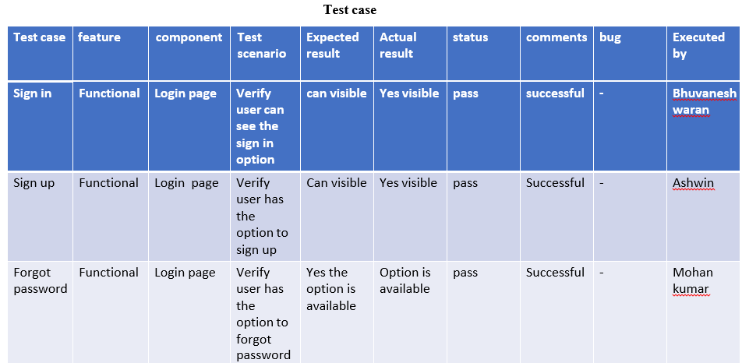

|  |  |  |  |  |  |  |  |  |  |
| --- | --- | --- | --- | --- | --- | --- | --- | --- | --- |
| **Fetch**  **news** | **Functional** | **Home**  **page** | **Verify user can get the**  **news** | **News will be eed to the app** | **404 error** | **Fail** | **unsuccess**  **ful** | **App integerati on**  **problem** | **Ragul rathna,**  **Ashwin** |
| Types of | Functional | Fetch | Types of | Weather, | Hover | Yes | successful | − | Mohan kumar, |
| news |  | news | news | Sport, | buttons |  |  |  | Ashwin. |
| available |  |  | available | Economy. | will be |  |  |  |  |
| in the |  |  |  |  | Shown. |  |  |  |  |
| fetch news |  |  |  |  |  |  |  |  |  |
| page |  |  |  |  |  |  |  |  |  |

# Result:

News tracker application using cloud is developed and executed at the level of completed progress.

# ADVANTAGES & DISADVANTAGES Advantages:-

* + In this app news is already categorization.
  + Easily accessible and portable.
  + Better user experience.
  + Apps help you convert visitors to loyal readers.
  + Minute by minute updates of news.
  + This app helps you to get local news updates instantly.
  + To explore and discover trending news and topics.
  + News feeds for you based on your interest.

# Disadvantages:-

* + Some apps demand premium subscription from user.
  + Occurance of Advertisment disturb the user.
  + Sometimes the news gives brief information.
  + Prevailance of fake and uncertain news can confuse the user lead to misconception.
  + Fake news may mislead the readers.

# CONCLUSION

We explored the feasibility of recognising patterns of news reading interactions and evaluated three adaptive interface designs for different news reader types. We show that from their interaction log, a specific user can be recognised as one of three kinds. The reader types emerging from the online survey are well defined and distinct. The evaluation of the three variant interfaces suggests that different news reader types need different user interfaces. We have demonstrated a method for monitoring users’ news reading behaviour and inferring news reader type from it. In the future we will further explore the design of adaptive interfaces, in order to be in a position to demonstrate a complete adaptive mobile news framework providing automatic personalisation of news apps.

# FUTURE SCOPE

In the future we will further explore the design of adaptive interfaces, in order to be in a position to demonstrate a complete adaptive mobile news framework providing automatic personalisation of news apps.

# APPENDIX Source Code:

**Backend_ App.py**

from dotenv import dotenv_values from apiFetch import *

from flask import Flask

from flask_cors import CORS

from routes.register import Register

from routes.checkEmail import CheckEmail from routes.verify import Verify

from routes.getnews import * from routes.islogin import IsLogin from routes.login import Login from flask_restful import Api

from utils.apiFetch import apiRunner app = Flask( name )

api = Api(app)

data = dotenv_values(".env") app.config['SECRET_KEY'] = data["secret_key"] app.config['SECURITY_PASSWORD_SALT'] =

data["secured_password_salt"] apiRunner()

CORS(app, supports_credentials=True) api.add_resource(Login, '/login') api.add_resource(IsLogin,'/islogin') api.add_resource(CheckEmail, '/register/check') api.add_resource(Register, '/register') api.add_resource(Verify, '/register/verify') api.add_resource(Personal, '/news/recommended') api.add_resource(News, '/news/<topic>')

# Routes_ CheckEmail.py

from flask import request

from flask_restful import Resource from utils.dbQuery import selectQuery class CheckEmail(Resource):

def post(self): data=request.json email=str(data["email"])

res=selectQuery("SELECT email FROM USER WHERE EMAIL=?",(email,))

print(res) if(not res):

return {"status":True},200 return {"status":False},400

# Getnews.py

from random import random

from flask_restful import Resource

from utils.cookieChecker import token_required from utils.dbQuery import selectQuery

from utils.apiFetch import apiData import random

from utils.testData import retArray class Personal(Resource):

@token_required def get(email, self):

topicsArr = ["sport", "tech", "world", "finance", "politics", "business", "economics", "entertainment", "beauty", "travel", "music", "food",

"science", "cricket"]

fav = selectQuery("SELECT favourites from user where email=?", (email,))[

'FAVOURITES']

fav = fav.split(',') for x in fav:

topicsArr.remove(x) retArr = []

favList = []

# favList = retArray nonFavList = []

for x in fav: try:

data = apiData(x) except:

data=None

if (data is not None): for y in data:

favList.append(y)

try:

random.shuffle(favList)

favList = sorted(favList, key=lambda k: k['date'], reverse=True) except:

favList=[]

for x in topicsArr: try:

data = apiData(x) except:

data=None if(data is not None):

for y in data: nonFavList.append(y)

try:

random.shuffle(nonFavList)

nonFavList = sorted(nonFavList, key=lambda k: k['date'], reverse=True) except:

nonFavList=[]

retArr = favList+nonFavList return {"data": retArr}, 200

class News(Resource): @token_required

def get(email,self,topic):

topicsArr = ["headline","sport", "tech", "world", "finance", "politics", "business",

"economics", "entertainment", "beauty", "travel", "music", "food", "science", "cricket"]

if(topic not in topicsArr):

return {"status":"Not a valid topic"},404 try:

retArr=apiData(topic) random.shuffle(retArr)

retArr=sorted(retArr,key=lambda k:k['date'],reverse=True) except:

retArr=[]

return {"data":retArr},200

# Islogin.py

from flask import request, after_this_request from utils.password import checkPassword from flask_restful import Resource

from utils.cookieChecker import token_required class IsLogin(Resource):

@token_required def get(email, self):

return {"status": "Logged in"}, 200

# login.py

from datetime import datetime from flask_restful import Resource

from flask import request,after_this_request from utils.password import checkPassword from utils.dbQuery import *

from dateparser import parse

from utils.tokener import generate_confirmation_token from utils.emailSender import emailSender

import app import jwt

class Login(Resource): def post(self):

data=request.json ip=request.headers.get("ip") email=data["email"] password=data["password"]

queryRes=selectQuery("SELECT * from user where email=?",(email,)) res=checkPassword(password,queryRes["PASSWORD"])

if(not res):

return {"status":"Wrong credentials"},400 if(not queryRes["VERIFIED"]):

lastTime=parse(queryRes["RESEND_TIME"]) currTime=datetime.now()

diff=currTime-lastTime diff=diff.total_seconds() if(diff>3600):

token=generate_confirmation_token(email) emailSender(email,token)

insertQuery("UPDATE user set RESEND_TIME=? where email=?",(datetime.now(),email))

return {"status":"Not verified"},400 @after_this_request

def cookieSender(response): access_token=jwt.encode(

{"email":email,"ip":ip},app.app.config['SECRET_KEY']

) #

response.set_cookie("access_token",str(access_token),httponly=True,samesite= None,path="/")

#

response.set_cookie("email",str(email),httponly=True,samesite=None,path="/") response.headers.add('Set-Cookie',f'access_token={str(access_token)};

SameSite=None; Secure; HttpOnly; Path=/') response.headers.add('Set-Cookie',f'email={str(email)};

SameSite=None; Secure; HttpOnly; Path=/') return response

return{"status":"Successfully Logged in"},200

# Register.py

from datetime import datetime

from flask import request,after_this_request from flask_restful import Resource

from utils.dbQuery import insertQuery

from utils.emailSender import newEmailSender from utils.password import genHash

class Register(Resource): def post(self):

req=request.json name=req['name'] email=req['email'] password=req['password'] favourite=req['favourite'] fav=','.join(favourite)

if(name=='' or email=='' or password=='' or fav==''): return {"status":"Missing data"},404

password=genHash(password) t=(name,email,password,fav,datetime.now()) res=insertQuery('INSERT INTO user

(name,email,password,favourites,resend_time) values (?,?,?,?,?)',t) if(not res):

return {"status":"Error while registering"},400

@after_this_request def emailer(response):

newEmailSender(email) return response

return {"status":"Successfully registered"},200

# verify.py

from flask import request

from flask_restful import Resource from utils.tokener import confirm_token from utils.dbQuery import insertQuery

class Verify(Resource): def post(self):

data=request.json token=data["token"] email=confirm_token(token) if(not email):

return {"status":"Couldn't verify"},400

res=insertQuery("UPDATE user set verified=True where email=?",(email,))

if(not res):

return {"status":"Couldn't Update"},400 return {"status":"verified successfully"},200

**Utils_ apiFetch.py**

from datetime import datetime from time import sleep

import warnings

from dotenv import dotenv_values from threading import *

import requests

from dateparser import parse class Api:

warnings.simplefilter('ignore')

key = dotenv_values(".env")

key = key["key"]

apiMap = {}

mainApiMap = {}

url = "https://newscatcher.p.rapidapi.com/v1/latest_headlines"

headers = {

"X-RapidAPI-Key": str( key),

"X-RapidAPI-Host": "newscatcher.p.rapidapi.com"

}

def newCatcherRunner(self, title): querystring = {"topic": title, "lang": "en",

"media": "True", "country": "IN"} respone = requests.request(

"GET", url=self. url, headers=self. headers, params=querystring) respone = respone.json()

retArr = []

for x in respone["articles"]: newJson = {} newJson["url"] = x["link"] newJson["title"] = x["title"]

newJson["img"] = x["media"] newJson["topic"] = x["topic"] currTime = parse(x["published_date"])

newJson["date"] = currTime.strftime("%d/%m/%Y") retArr.append(newJson)

return retArr

def topHeadlinesFetcher(self):

querystring = {"topic":"news","lang": "en","media": "True", "country": "IN"}

respone = requests.request("GET", url=self. url, headers=self. headers, params=querystring)

respone = respone.json() retArr = []

for x in respone["articles"]: newJson = {} newJson["url"] = x["link"] newJson["title"] = x["title"]

newJson["img"] = x["media"] newJson["topic"] = x["topic"] currTime = parse(x["published_date"])

newJson["date"] = currTime.strftime("%d/%m/%Y") retArr.append(newJson)

self. apiMap["headline"]=retArr print("headline fetched at "+str(datetime.now()))

def newsCatcherApiFetcher(self):

arr = ["sport", "tech", "world", "finance", "politics", "business",

"economics", "entertainment", "beauty", "travel", "music", "food", "science"] for x in arr:

self. apiMap[x] = self. newCatcherRunner(x) print("NewsCatcher fetched at "+str(datetime.now()))

def cricketFetcher(self):

url = "https://cricbuzz-cricket.p.rapidapi.com/news/v1/index" headers = {

"X-RapidAPI-Key": self. key,

"X-RapidAPI-Host": "cricbuzz-cricket.p.rapidapi.com"

}

response = requests.request("GET", url, headers=headers) response = response.json()

response = response["storyList"] retArr = []

for x in response: try:

x = x["story"] newJson = {}

newJson["url"] = f'https:/[/www.cricbu](http://www.cricbuzz.com/cricket-news/)z[z.com/cricket-news/{x["id](http://www.cricbuzz.com/cricket-news/)"]}/newsTrakcer' newJson["title"] = x["hline"]

newJson["image"] = f'https:/[/www.cricbuz](http://www.cricbuzz.com/a/img/v1/500x500/i1/c)z[.com/a/img/v1/500x500/i1/c](http://www.cricbuzz.com/a/img/v1/500x500/i1/c){x["id"]}/abc.jpg'

currTime = datetime.fromtimestamp(int(x["pubTime"])/1e3) newJson["date"] = currTime.strftime("%d/%m/%Y") newJson["topic"] = "cricket"

retArr.append(newJson) except:

pass

self. apiMap["cricket"] = retArr print("Cricbuzz fetched at "+str(datetime.now()))

def newsCatcherThreader(self):

while True:

print("NewsCatcher fetching. at "+str(datetime.now()))

try:

self. newsCatcherApiFetcher() self. mainApiMap = self. apiMap

except:

print("Error NewsCatcher fetching. at "+str(datetime.now()))

pass sleep(30*60)

def topHeadlinesThreader(self): while True:

print("Headline fetching. at "+str(datetime.now()))

try:

self. topHeadlinesFetcher()

self. mainApiMap = self. apiMap except:

print("Error headline fetching. at "+str(datetime.now()))

pass sleep(30*60)

def cricbuzzThreader(self): while True:

print("Cricbuzz fetching. at "+str(datetime.now()))

try:

self. cricketFetcher()

self. mainApiMap = self. apiMap except:

print("Error Cricbuzz fetching. at "+str(datetime.now()))

pass sleep(15*60)

def dataGetter(self, topic):

return self. mainApiMap[str(topic)] a = Api()

def apiRunner():

t1 = Thread(target=a.topHeadlinesThreader) t2 = Thread(target=a.newsCatcherThreader) t3 = Thread(target=a.cricbuzzThreader) t1.daemon=True

t2.daemon=True t3.daemon=True t1.start() t2.start() t3.start()

def apiData(topic):

return a.dataGetter(topic)

**CookieChecker.py**

import app

from functools import wraps import jwt

from flask import request,after_this_request def token_required(f):

@wraps(f)

def decorated(*args, **kwargs):

token = request.cookies.get("access_token") try:

data = jwt.decode(token, app.app.config['SECRET_KEY'],algorithms=['HS256']) ip=request.headers.get("ip")

cookieIp=data['ip'] if(ip!=cookieIp):

resp={"status":"not logged in"} @after_this_request

def deleter(response): response.delete_cookie("access_token",path="/") response.delete_cookie("email",path="/")

return response return resp,401

except:

resp = {"status":"not logged in"} @after_this_request

def deleter(response): response.delete_cookie("access_token",path="/") response.delete_cookie("email",path="/")

return response return resp, 401

return f(data['email'],*args, **kwargs) return decorated

**dbConfig.py**

from dotenv import dotenv_values def getDbCred():

data=dotenv_values(".env") dsn_hostname=data["ibm_host_name"] dsn_uid=data["ibm_user_id"] dsn_pwd=data["ibm_password"] dsn_driver=data["ibm_driver"] dsn_database=data["ibm_db_name"] dsn_port=data["ibm_port"] dsn_protocol=data["ibm_protocol"] dsn=(

"DATABASE={1};"

"HOSTNAME={2};"

"PORT={3};"

"PROTOCOL={4};"

"UID={5};"

"PWD={6};"

"SECURITY=SSL").format(dsn_driver,dsn_database,dsn_hostname,dsn_p ort,dsn_protocol,dsn_uid,dsn_pwd)

return dsn

# dbQuery.py

import ibm_db

from utils.dbConfig import getDbCred conn=ibm_db.connect(getDbCred(),"","") def selectQuery(query,params=None):

try:

stmt=ibm_db.prepare(conn,query) if(params==None):

ibm_db.execute(stmt) data=ibm_db.fetch_assoc(stmt) return data

ibm_db.execute(stmt,params) data=ibm_db.fetch_assoc(stmt) return data

except:

return False

def insertQuery(query,params): try:

stmt=ibm_db.prepare(conn,query) ibm_db.execute(stmt,params) return True

except:

return False

# emailSender.py

from future import print_function

from utils.tokener import generate_confirmation_token import sib_api_v3_sdk

import app

from sib_api_v3_sdk.rest import ApiException from datetime import datetime

def emailSender(email, token):

configuration = sib_api_v3_sdk.Configuration()

configuration.api_key['api-key'] = app.data['mail_api_key'] api_instance = sib_api_v3_sdk.TransactionalEmailsApi(

sib_api_v3_sdk.ApiClient(configuration)) now = datetime.now()

dt_string = now.strftime("%d/%m/%Y %H:%M:%S") msg = {}

msg['Subject'] = "Verfiy your NewsTracker Account" msg['From'] = {"name": "News Tracker Dev Team",

"email": "[verify@newstracker.com"}](mailto:verify@newstracker.com) msg['To'] = [{"email": email}] msg['Text']=f'Please click this <a

href="http://127.0.0.1:5500/frontend/pages/verify.html?token={token}">link</a

> to verify your account' html = f"""\

<html>

<head></head>

<body>

<p>நன் றி, for joining NewsTracker ß:lH</p>

<br>

<p>Hurray , you just registerd at NewsTracker<br><br>

Please click the following link to verify your account:<br>

<a href="http://127.0.0.1:5500/frontend/pages/verify.html?token={token}">Click Here to Verify ◆“◆ </a>

</p>

<br>

<p> Note: This link expires within one hour from the time sent</p>

<br><br>

<p>Regrads,<br></p>

<p><a href="https://localhost:5000">NewsTracker Dev Team</a></p>

<br><br>

<p>Email sent at {dt_string}</p>

</body>

</html> """

send_smtp_email = sib_api_v3_sdk.SendSmtpEmail( to=msg['To'], html_content=html, sender=msg['From'],

subject=msg['Subject'],text_content=msg['Text']) try:

api_response = api_instance.send_transac_email(send_smtp_email) print(api_response)

except ApiException as e:

print("Exception when calling SMTPApi->send_transac_email: %s\n" %

e)

def newEmailSender(email):

token = generate_confirmation_token(email) emailSender(email, token)

# password.py

import bcrypt

def genHash(password): salt=bcrypt.gensalt() bytes=password.encode('utf-8') hash=bcrypt.hashpw(bytes,salt) print(hash)

return hash

def checkPassword(password,hash): hash=hash.encode('utf-8') bytes=password.encode('utf-8') res=bcrypt.checkpw(bytes,hash) return res

# tokener.py

from itsdangerous import URLSafeTimedSerializer import app

def generate_confirmation_token(email): serializer=URLSafeTimedSerializer(app.app.config['SECRET_KEY']) return

serializer.dumps(email,salt=app.app.config['SECURITY_PASSWORD_SALT']

)

def confirm_token(token,expiration=3600): serializer=URLSafeTimedSerializer(app.app.config['SECRET_KEY']) try:

email=serializer.loads( token,

salt=app.app.config['SECURITY_PASSWORD_SALT'], max_age=expiration

)

except:

return False return email

# Frontend_ Bookmarks.html

<!DOCTYPE html>

<html lang="en">

<head>

<meta charset="UTF-8">

<meta http-equiv="X-UA-Compatible" content="IE=edge">

<meta name="viewport" content="width=device-width, initial-scale=1.0">

<link rel="stylesheet" href="../css/bookmarks.css">

<title>Document</title>

</head>

<body>

<nav id="head_nav">

<div class="title_container">

<img id="ham_icon" src="../assets/hamburger 1.svg" alt="ham_icon">

<h1 id="app_name">News App</h1>

<!-- <div class="search_container">

<input type="text" id="search_box"

placeholder="Search for topics, locations and resources"

>

</div> -->

<img id="user_icon" src="../assets/user 1.svg" alt="user_icon">

<div class="profile_div display_none">

<a class="bookmarked_link" href="./bookmarks.html"><h3 class="bookmarked">Bookmarks</h3></a>

<h3 class="logout">Logout</h3>

</div>

</div>

<div class="menu_container">

<h3 class="nav_button selected_nav_item">Home</h3>

<h3 class="nav_button">India</h3>

<h3 class="nav_button">World</h3>

<h3 class="nav_button">Technology</h3>

<h3 class="nav_button">Entertainment</h3>

<h3 class="nav_button">Sports</h3>

<h3 class="nav_button">Science</h3>

<h3 class="nav_button">Health</h3>

</div>

</nav>

<section id="home">

<div class="news_wrapper">

<img class="bookmark" src="../assets/bookmark-solid.svg" alt="" />

<a class="news_cont" href="./news.html">

<div class="img_cont">

<img src="../assets/pexels-cottonbro-3944418 1.png" alt="" class="news_thumbnail">

</div>

<div class="news_content">

<h2 class="news_heading">JSV effect</h2>

<p>Lorem ipsum dolor sit amet consectetur adipisicing elit. Rerum eveniet quibusdam autem iste, eligendi nihil quod molestias facere incidunt quia officia atque distinctio consequuntur qui, suscipit voluptates quasi minus ipsum.</p>

</div>

</a>

</div>

</section>

<script src="../js/main.js"></script>

</body>

</html>

# Index.html

<!DOCTYPE html>

<html lang="en">

<head>

<meta charset="UTF-8">

<meta http-equiv="X-UA-Compatible" content="IE=edge">

<meta name="viewport" content="width=device-width, initial-scale=1.0">

<link rel="stylesheet" href="../css/index.css">

<title>Document</title>

</head>

<body>

<nav id="head_nav">

<div class="title_container">

<img id="ham_icon" src="../assets/hamburger 1.svg" alt="ham_icon">

<h1 id="app_name">News App</h1>

<!-- <div class="search_container">

<input type="text" id="search_box"

placeholder="Search for topics, locations and resources"

>

</div> -->

<img id="user_icon" src="../assets/user 1.svg" alt="user_icon">

<div class="profile_div display_none">

<a class="bookmarked_link" href="./bookmarks.html"><h3 class="bookmarked">Bookmarks</h3></a>

<h3 class="logout">Logout</h3>

</div>

</div>

<div class="menu_container">

<h3 class="nav_button selected_nav_item">Home</h3>

<h3 class="nav_button">India</h3>

<h3 class="nav_button">World</h3>

<h3 class="nav_button">Technology</h3>

<h3 class="nav_button">Entertainment</h3>

<h3 class="nav_button">Sports</h3>

<h3 class="nav_button">Science</h3>

<h3 class="nav_button">Health</h3>

</div>

</nav>

<section id="home">

<div class="horizontal_content">

<div class="news_wrapper">

<img class="bookmark" src="../assets/bookmark-regular.svg" alt=""

/>

<a class="news_cont" href="./news.html">

<div class="img_cont">

<img src="../assets/pexels-cottonbro-3944418 1.png" alt=""

class="news_thumbnail">

</div>

<div class="news_content">

<h2 class="news_heading">JSV effect</h2>

</div>

</a>

</div>

<div class="news_wrapper">

<img class="bookmark" src="../assets/bookmark-regular.svg" alt=""

/>

<a class="news_cont" href="./news.html">

<div class="img_cont">

<img src="../assets/pexels-cottonbro-3944418 1.png" alt=""

class="news_thumbnail">

</div>

<div class="news_content">

<h2 class="news_heading">JSV effect</h2>

</div>

</a>

</div>

<div class="news_wrapper">

<img class="bookmark" src="../assets/bookmark-regular.svg" alt=""

/>

<a class="news_cont" href="./news.html">

<div class="img_cont">

<img src="../assets/pexels-cottonbro-3944418 1.png" alt="" class="news_thumbnail">

</div>

<div class="news_content">

<h2 class="news_heading">JSV effect</h2>

</div>

</a>

</div>

<div class="news_wrapper">

<img class="bookmark" src="../assets/bookmark-regular.svg" alt=""

/>

<a class="news_cont" href="./news.html">

<div class="img_cont">

<img src="../assets/pexels-cottonbro-3944418 1.png" alt=""

class="news_thumbnail">

</div>

<div class="news_content">

<h2 class="news_heading">JSV effect</h2>

</div>

</a>

</div>

</div>

<div class="news_wrapper">

<img class="bookmark" src="../assets/bookmark-regular.svg" alt="" />

<a class="news_cont" href="./news.html">

<div class="img_cont">

<img src="../assets/pexels-cottonbro-3944418 1.png" alt="" class="news_thumbnail">

</div>

<div class="news_content">

<h2 class="news_heading">JSV effect</h2>

<p>Lorem ipsum dolor sit amet consectetur adipisicing elit. Rerum eveniet quibusdam autem iste, eligendi nihil quod molestias facere incidunt quia officia atque distinctio consequuntur qui, suscipit voluptates quasi minus ipsum.</p>

</div>

</a>

</div>

</section>

<script src="../js/main.js"></script>

<script src="../js/index.js" type="module"></script>

</body>

</html>

# Login.html

<!DOCTYPE html>

<html lang="en">

<head>

<meta charset="UTF-8">

<meta http-equiv="X-UA-Compatible" content="IE=edge">

<meta name="viewport" content="width=device-width, initial-scale=1.0">

<title>Login and Sign Up Page</title>

<!--font awesome-->

<link rel="stylesheet" href="https://cdnjs.cloudflare.com/ajax/libs/font- awesome/6.2.0/css/all.min.css">

<!--custom css file link-->

<link rel="stylesheet" href="../css/login.css">

</head>

<body>

<div class="container" id="container">

<div class="form-container sign-up-container">

<form id="signup-form" onsubmit="return false;">

<h1>Create Account</h1>

<span>You can use your custom email</span>

<input type="text" placeholder="NAME" class="box" required autocomplete="name">

<input type="email" placeholder="E-mail" class="box" required autocomplete="email">

<input type="password" placeholder="PASSWORD" class="box" required autocomplete="current-password">

<input type="password" placeholder="RE-ENTER PASSWORD" class="box" required autocomplete="current-password">

<button class="btn">Sign Up</button>

<h2></h2>

</form>

</div>

<div class="form-container sign-in-container">

<form onsubmit="return false;">

<h1>Sign In</h1>

<span>Enter your sign in credentials</span>

<input type="email" placeholder="E-mail" class="box" autocomplete="email">

<input type="password" placeholder="PASSWORD" class="box" autocomplete="current-password">

<button class="btn">Sign In</button>

<h2></h2>

</form>

</div>

<div class="overlay-container">

<div class="overlay">

<div class="overlay-panel overlay-left">

<div class="container-checkbox">

<ul class="ks-cboxtags">

<li><input type="checkbox" id="checkboxOne" value="sport" checked><label for="checkboxOne">sport</label></li>

<li><input type="checkbox" id="checkboxTwo" value="tech" checked><label for="checkboxTwo">tech</label></li>

<li><input type="checkbox" id="checkboxThree" value="world"><label for="checkboxThree">world</label></li>

<li><input type="checkbox" id="checkboxFour" value="finance"><label for="checkboxFour">finance</label></li>

<li><input type="checkbox" id="checkboxFive" value="politics" checked><label for="checkboxFive">politics</label></li>

<li><input type="checkbox" id="checkboxSix" value="business"><label for="checkboxSix">business</label></li>

<li><input type="checkbox" id="checkboxSeven" value="economics"><label for="checkboxSeven">economics</label></li>

<li><input type="checkbox" id="checkboxEight" value="entertainment"><label for="checkboxEight">entertainment</label></li>

<li><input type="checkbox" id="checkboxNine" value="beauty"><label for="checkboxNine">beauty</label></li>

<li><input type="checkbox" id="checkboxTen" value="travel"><label for="checkboxTen">travel</label></li>

<li><input type="checkbox" id="checkboxEleven" value="music"><label for="checkboxEleven">music</label></li>

<li><input type="checkbox" id="checkboxTwelve" value="food"><label for="checkboxTwelve">food</label></li>

<li><input type="checkbox" id="checkboxThirteen" value="science"><label for="checkboxThirteen">science</label></li>

<li><input type="checkbox" id="checkboxFourteen" value="cricket"><label for="checkboxFourteen">cricket</label></li>

</ul>

</div>

<h1>Already registed ?</h1>

<button class="btn" id="signin">sign in</button>

</div>

<div class="overlay-panel overlay-right">

<h1>Welcome to latest world updates!</h1>

<button class="btn" id="signup">sign up</button>

</div>

</div>

</div>

</div>

<script src="../js/login.js" type="module"></script>

</body>

</html>

# News.html

<!DOCTYPE html>

<html lang="en">

<head>

<meta charset="UTF-8">

<meta http-equiv="X-UA-Compatible" content="IE=edge">

<meta name="viewport" content="width=device-width, initial-scale=1.0">

<link rel="stylesheet" href="../css/news.css">

<title>Document</title>

</head>

<body>

<nav id="head_nav">

<div class="title_container">

<img id="ham_icon" src="../assets/hamburger 1.svg" alt="ham_icon">

<h1 id="app_name">News App</h1>

<!-- <div class="search_container">

<input type="text" id="search_box"

placeholder="Search for topics, locations and resources"

>

</div> -->

<img id="user_icon" src="../assets/user 1.svg" alt="user_icon">

<div class="profile_div display_none">

<h3 class="logout">Logout</h3>

</div>

</div>

<div class="menu_container">

<h3 class="selected_nav_item">Home</h3>

<h3>India</h3>

<h3>World</h3>

<h3>Technology</h3>

<h3>Entertainment</h3>

<h3>Sports</h3>

<h3>Science</h3>

<h3>Health</h3>

</div>

</nav>

<iframe src="" frameborder="0">

<!-- news API -->

</iframe>

<script src="../js/main.js"></script>

</body>

</html>

# Verify.html

<!DOCTYPE html>

<html lang="en">

<head>

<meta charset="UTF-8" />

<meta http-equiv="X-UA-Compatible" content="IE=edge" />

<meta name="viewport" content="width=device-width, initial-scale=1.0" />

<link rel="stylesheet" href="../css/verify.css" />

<title>Verify</title>

</head>

<body>

<nav id="head_nav">

<div class="title_container">

<h1 id="app_name">News Tracker</h1>

</div>

</nav>

<div class="status-cont">

<div class="welcome-text">Please wait...=+_T=‡

</div>

</body>

</div>

<script src="../js/verify.js" type="module"></script>

</html>

# GitHub

[IBM-EPBL/IBM-Project-53564-1661418220](https://github.com/IBM-EPBL/IBM-Project-53564-1661418220)